Model Falsification

Part 1: Principles and Literature

Section 1: General Principles

The basic principle is that we start with the simplest model available. Any added “complexity” requires three-fold justification:

- The current “best” model cannot attain the particular behaviour/measurement we require
- The proposed model can attain the particular behaviour/measurement we require
- The proposed model can attain the particular behaviours/measurements which originally justified the current “best” model.

The first justification is a universal statement, i.e. For every (reasonable) input, the output of the model does not have the specific property required. We can either prove this with a logical/mathematical argument or we can offer evidence of this by providing evidence of absence of the property.

The second justification is an existence statement. Therefore, a single instance of the result is all that is required. However, a robust result, as evidenced by a large proportion of a large sample showing the property holds, is desired.

The third justification is another existence statement and therefore the previous paragraph holds here too.

Implicit in all of this is that the model’s inputs are only changed between tests if the test seeks the result of altered inputs. In other words, it would be inconsistent/inadequate to use one initial condition to show rate-capacity during discharge while using another initial condition to show that the resistance model gives a reasonable result. These results should occur simultaneously for any initial conditions. Hence, we should seek to show instances of the model producing a set of properties all with the same set of inputs (except where the input is required to be changed for the test, e.g. current).

Section 2: Published Models

It should be obvious that zero-dimensional (or lumped) models are more simple than spatially resolved models. The question then must be asked, is there any measurable which the published lumped models cannot adequately simulate but spatially resolved models can?

Section 3: Lumped Models

The literature does not offer a clean comparison of the available models. Some are tested in narrow ways which does not allow the comparison we need. For example, Zhang et al. (2015) offers a lumped model for resistance during discharge. However, we are not given the performance for charge. Marinescu et al. (2016) gives us both charge and discharge behaviours, but not resistance. Moreover, the discharge curve of Zhang et al. (2015) is dependent on the Bruggeman relation for active surface area, while Marinescu et al. (2016) leave the active surface area as a non-dynamic constant. Therefore, any difference in performance could be attributed to the electrochemical pathway as well as the dynamic equations. In any case, if Marinescu et al. (2016) produces adequate resistance curves, then we have no reason to use Zhang et al. (2015) because the former is simpler than the latter. If Marinescu et al. (2016) does not produce adequate resistance curves, then we still are required to test the charge curves Zhang et al. (2015), which we know will not produce the infinite voltage/capacity relation with current because the shuttle effect is not included.

Neither of the above models give dynamic relations for temperature. Hua et al. (2019) does provide this model, but it is theoretically impossible for constant temperature cells (such as those in Hunt et al. (2018), because dTc/dt = 0 leads to a contradiction in the other variables).

In any case, Marinescu et al. (2016) gives a good argument against Mikhaylik & Akridge (2004) and in favour of the former’s model as the leading candidate. So, let us begin with that model.

Part 2: Simulation Tests

Section 1: Marinescu et al. (2016)

As noted above, if Marinescu et al. (2016) yields resistance curves during discharge similar to that of Zhang et al. (2015) then there is no need to continue with the latter without serious justification. Using the model and inputs described in Marinescu et al. (2016) we find the following results. First, we need not fit the exact resistance curve because we are looking for the general shape of the curve.

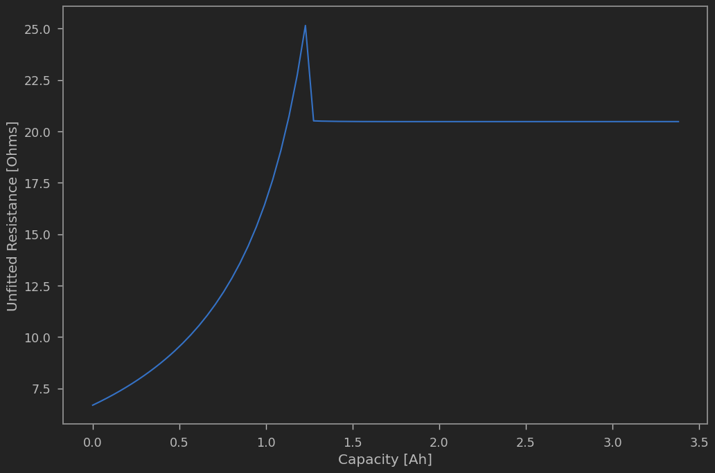
No parameter values could make this curve adequate because the fundamental problem is that the Li-ion mass becomes constant in the latter half of discharge.
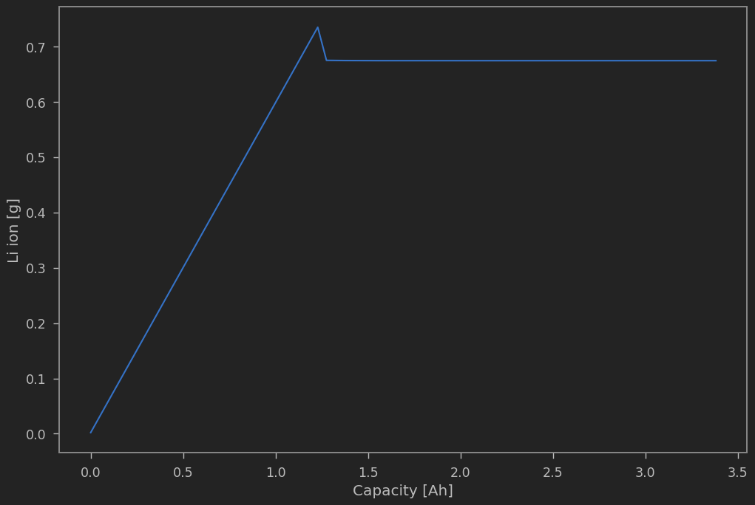

We can state that this problem is due to the chemical pathway by first removing the concerns about parameter values on theoretical grounds. Then we can discuss initial conditions.

In the model, S_8^{0} is reduced to S_4^{2-}. Then S_4^{2-} is reduced to both S_2^{2-} and S_1^{2-}. It is only S_1^{2-} which precipitates. This implies that as S_4^{2-} is reduced, some of the produce will go on to be precipitated and hence lessen the ionic mass. However, some of the product will be stored in S_2^{2-} and never alter from there. Therefore, what is observed in the Li ion figure is that higher order species reduce into S_1^{2-} and S_2^{2-} in equal measure. Any parameter effects on precipitation alter the dynamics after this reduction. Indeed, equations (8c) and (8d) show that the product of the low-plateau reaction results, regardless of parameters, in equal measures to both of these lower order species. If all of S_8^0 and S_4^{2-} is reduced as well as all of S_1^{2-} is precipitated, still half of the higher order products will be held in S_2^{2-}.

The effects of initial conditions can be observed in the following two plots. The initial conditions are found by assuming that i_L = 0 and so i_H = I. The former equation implies V = E_L, which can be used to solve for S_2^{2-} in terms of S_4^{2-} and S_1^{2-}, given V. The latter equation is a root finding problem for S_8^0 in terms of S_4^{2-}. We can use the theoretical capacity formula from Marinescu et al. (2018) to set S_4^{2-} in terms of S_8^{0}, then insert that into the root finding problem. Only a single S_8^{0} is permitted for a given voltage, capacity, and current. Once found, S_4^{2-} is easily solved. Finally, we set S_1^{2-} as a list of possible values over many orders of magnitudes. Each S_1^{2-} is used to solve for S_2^{2-} and the simulation is performed. Below are the discharge voltage and Li ion simulations given each initial condition. The Li ion plot shows Li – max(Li) + 1 in order to keep all curves geometrically comparable. All we need is the shape of the curve, so these shifts are unimportant.

Clearly, the initial conditions do not play a role in altering the Li ion [g] dynamics and hence do not alter the resistance curve dynamics. This chemical pathway is inadmissible. We must, at a minimum, change the chemical pathway of the lower plateau into two different pathways to allow all ionic species to reduce down to S_1^{2-} and hence precipitate at end of discharge.

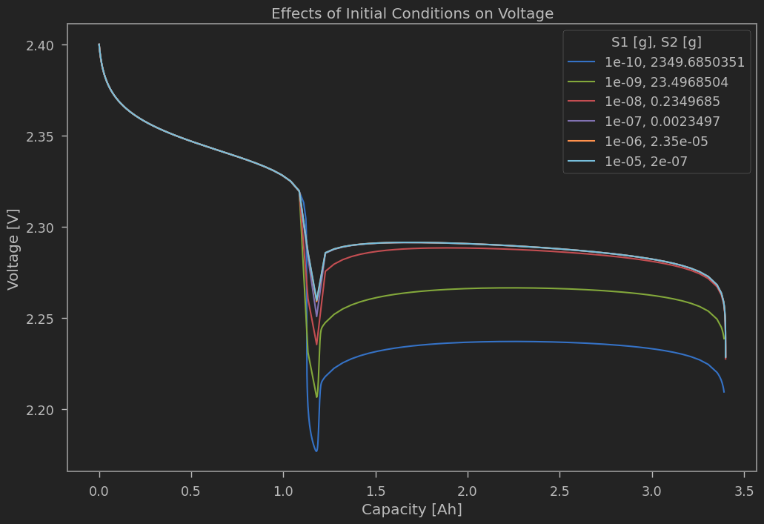
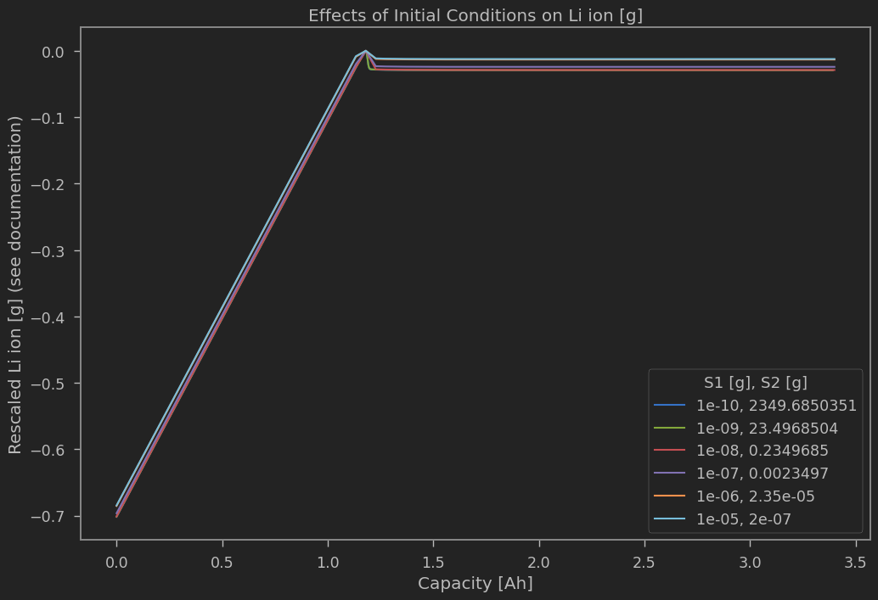

Section 2: Chemistry 4

Basic Model Discharge
Instead of moving directly to Zhang et al. (2015), we can alter the chemical pathway of Marinescu et al. (2016, 2018) to allow for a full reduction of ionic species. The new chemical pathway (for historical reasons which should be changed) will be referred to as chemistry 4 and is

S_{8}^{0} + 4e^{-} => 2 S_{4}^{2-}
S_{4}^{2-} + 2e^{-} => 2S_{2}^{2-}
S_{2}^{2-} + 2e^{-} => 2S^{2-}

The only difference is that the low plateau reaction has been split into two sequential reactions.

We first need to justify this model by showing that this chemical pathway resolves the resistance issue. If not, then that is an non sequitur. We find initial conditions in a very similar way to the above analysis for Marinescu et al. (2016). Otherwise, the parameters are essentially the same but where the new parameters are given similar values.

Disregarding the capacity (something I haven’t figured out theoretically full yet) we have a reasonable discharge voltage curve

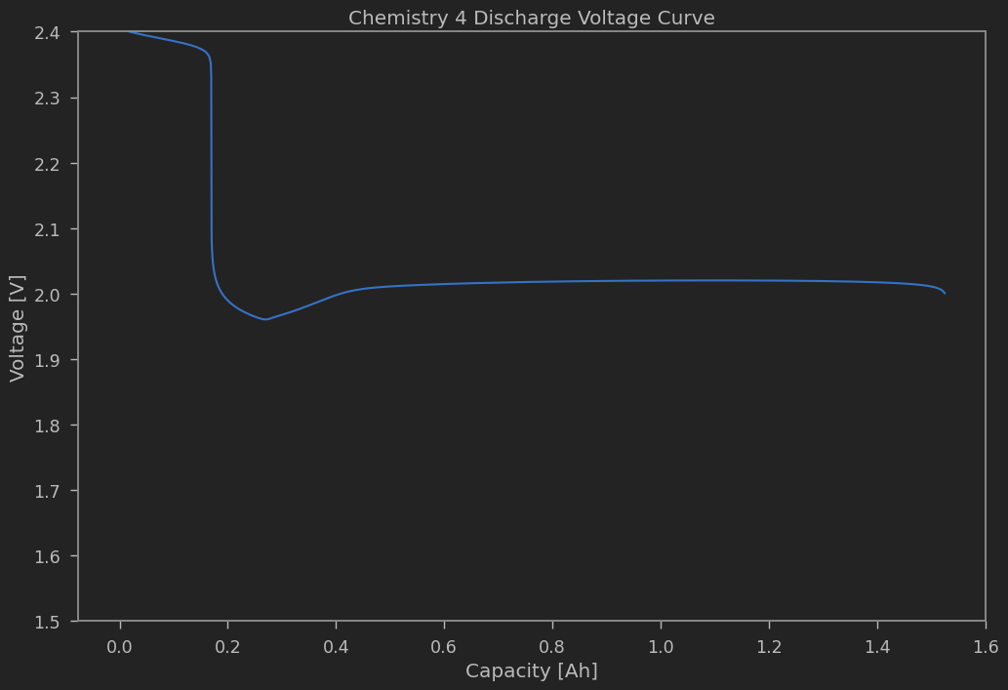

We also have a reasonable Li ion mass dynamic which is illustrated by the next figure.

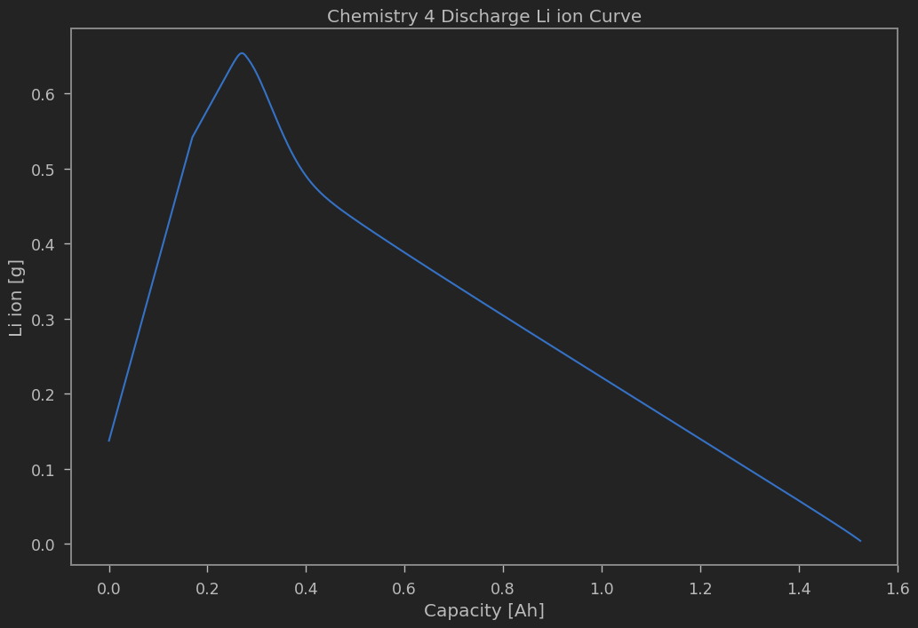
This translates into a reasonable appearing “resistance” curve, where we have eyeballed the values to get a reasonable curve.

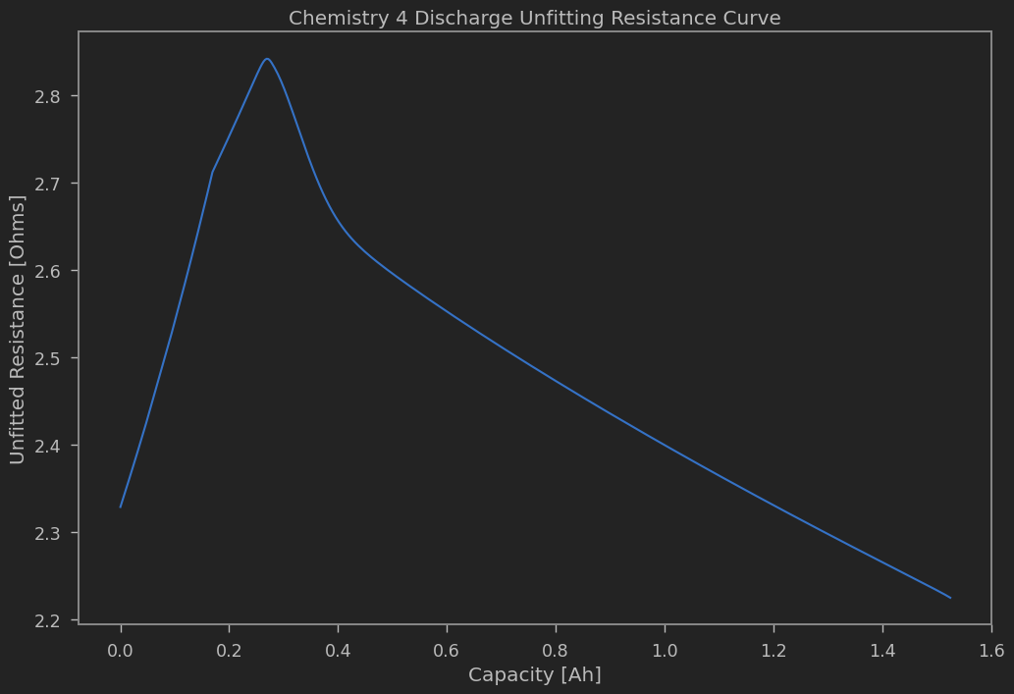

Notice that we have a unique initial condition up to both the initial amount of precipitated sulfur as well as the parameter values. Let us now observe the effect of varying the initial values of precipitated sulfur.

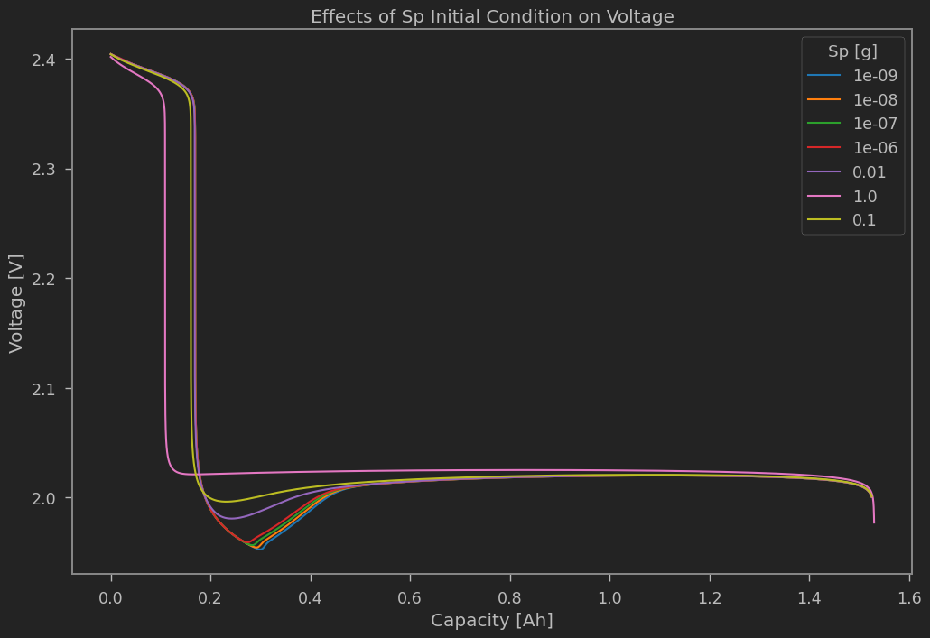
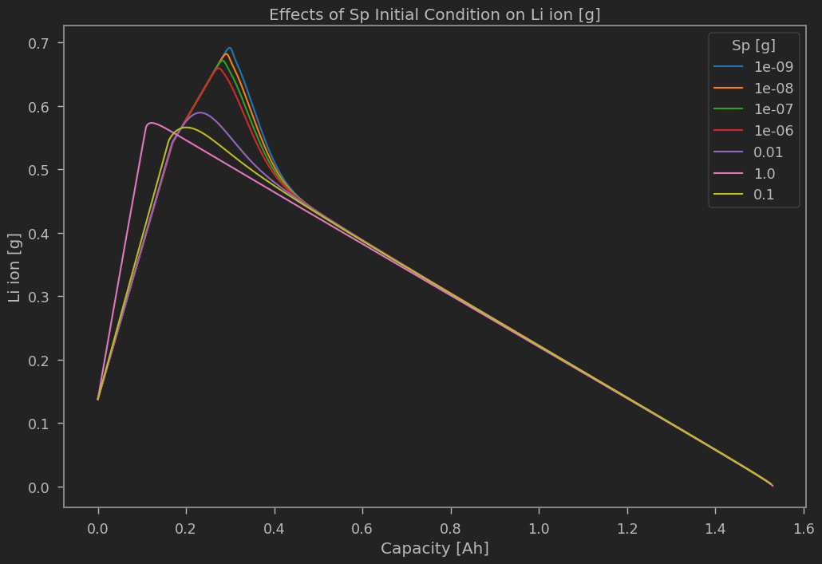

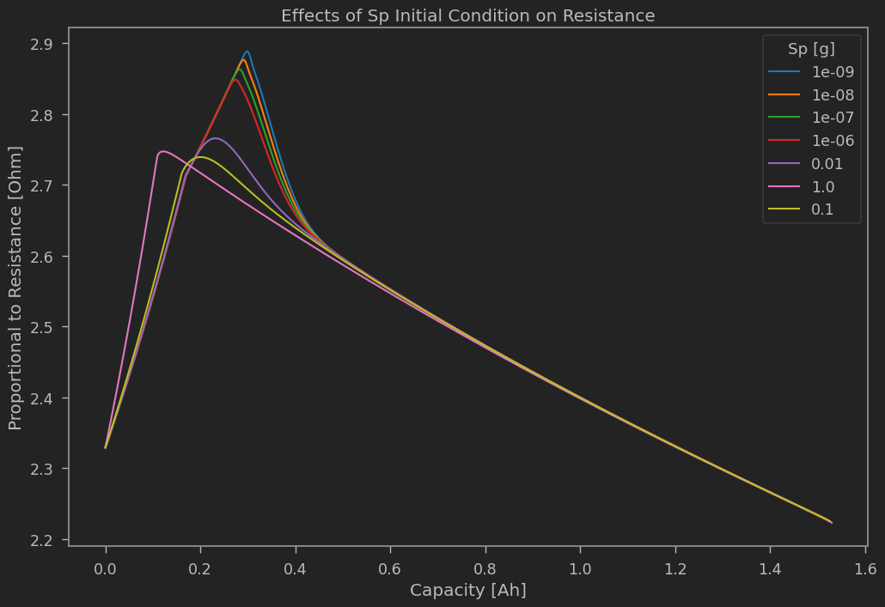

From the above simulations, we consistently see that the S_8^0 has negative (but near zero, i.e. 10^{-32}) values. Therefore, we should not expect that this model (given its parameters) can provide the full discharge (in terms of voltage) that we should expect.

Moreover, we have shown that the effects of the initial precipitated sulfur is primarily observed at the beginning and middle of discharge, but has no effect on capacity. This is a key insight. With the formulation for initial conditions which seeks to find consistent initial conditions with the following equations

i_h = I
i_m = 0
i_l = 0

we find we have a free variable for the initial condition. We can formulate this as the initial condition for S_8^0. However, we require S_8^0 to be approximately 0.4 g in order to achieve the high plateau capacity which we observe in the cells from Hunt et al. (2015). Setting this value, we find that the relation between the initial values of S_8^0 and S_4^{2-} is monotonic and increasing. This is an issue because the initial values of S_4^{2-} are too large for the given cell’s capacity. If we decrease S_8^0 we sacrifice the high-to-low transition of the voltage curve during discharge for the capacity of the cell itself. Increasing S_8^0 to obtain the correct transition point necessarily increases the cell capacity. The differences in capacity found are not minor and are therefore grounds for believing the model is falsified.

What we have achieved from this model, however, is the observation of the lower plateau electrochemical pathway which yields the correct (general) behaviour of the resistance curve during discharge. To fix the issue with the capacity of the cell, we introduce a new species, S_6^{2-} which gives us two degrees of freedom for the initial conditions. This new model produces the correct capacity both at the point of transition and over the entire discharge. Note that if we used the theoretical capacity as an addition restriction, then we get a unique initial condition (modulo parameters) but the actual capacity of the simulation is far less than expected.

Section 3: Chemistry 5

We have not yet falsified this model based on the above simulations. However, the shape of the discharge voltage and resistance curves are not quite what we should expect. From prior experience, it is helpful to modulate the partial current functions. Note that doing so would not undo the falsification of Marinescu et al. (2016) because the problem was the chemical pathway rather than the dynamical system.

We have two known and accepted options: make the active surface area a dynamic variable or use some concentration dependence. With the former, we would also need to add in the porosity variable. This complicates the model further and would need strong justification. Within the latter, we have the typical function which requires at least one parameter for each ionic species, or we can use the sigmoid function formulation which requires two parameters in total. Thus, the sigmoid concentration function is the simplest addition to the model which is meant to resolve the particular shape of the voltage curve (and probably the resistance curve). Let us proceed to observe those simulations.

Sigmoid Concentration Dependence Discharge

Using the sigmoid concentration function we can make substantive gains in accuracy by using only two parameters. Eyeballing these parameters, we can compare the performance between the data from Hunt et al. (2015) and our simulation.

The above chart shows a significant improvement on the qualitative features of the discharge curve. Moreover, we can observe the Li ion mass dynamics and the “resistance” curve.

We can now apply two further falsification tests to this discharge. First, we have a unique (modulo parameters and precipitated sulfur) initial conditions based on voltage, capacity, and current. However, we should expect that different currents should still produce a similar initial voltage. We can call this property “initial voltage stability with respect to current”. Second, we should expect higher currents to reduce capacity and lower currents to increase capacity. We can perform both of these tests simultaneously, as shown in the next plot.

Note that the use of the sigmoid concentration function would alter the initial condition solution. We expect that the difference is moderate and the initial voltage stability is evidence that these slight modifications are not consequential.

Sigmoid Concentration Dependence Charge

Since we cannot obtain lower discharge voltages at end of discharge with the simple model, we can use the end of discharge with concentration dependence as a reasonable initial condition for charge, regardless of the modifications we make to the model. The following plot shows the experimental charge, the basic chemistry 4 model, and the eye-ball fitted chemistry 4 model with sigmoid concentration dependence. The next plot shows the Li ion mass and the subsequent plot presents the “resistance”.

We expect several features from any model. First, we expect the initial charge voltage dynamics to be dependent on the depth of discharge (and hence produce the charge kink). We can observe this by taking various initial conditions from the various points along the discharge of the previous simulation.

Similar to rate-capacity dependence during discharge, we should expect initial voltage stability with respect to current for the charge phase as well as the infinite-capacity/voltage relation due to current. The following plot illustrates these features.

Absence of evidence does not imply evidence of absence. However, sampling inputs is not absence of evidence but evidence of search with not positive result and hence is indeed evidence of absence.

